I need to run output for server_frame.java first, then I run output for client_frame.java.

This is output for server_frame.java

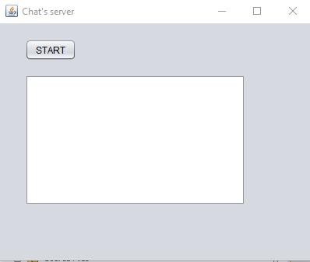

Then I click the button (START)

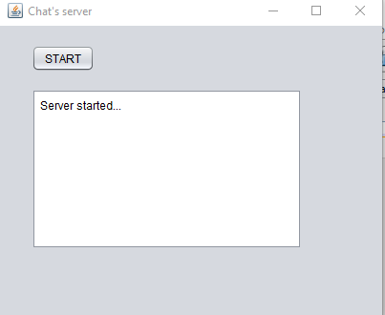

Then I run the output for client_frame.java

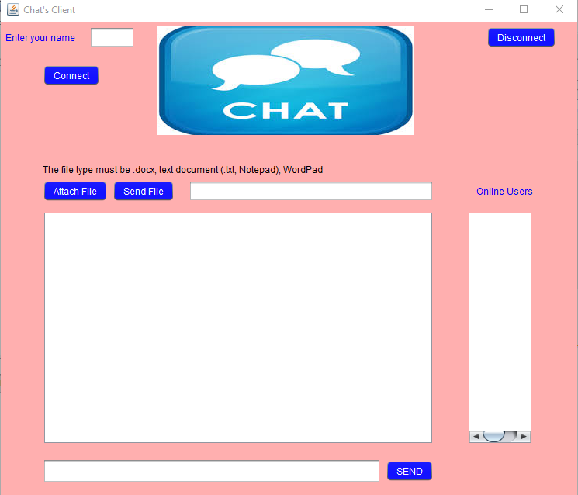

Then I enter the name and click button (Connect). Then the name is appeared on the right frame.

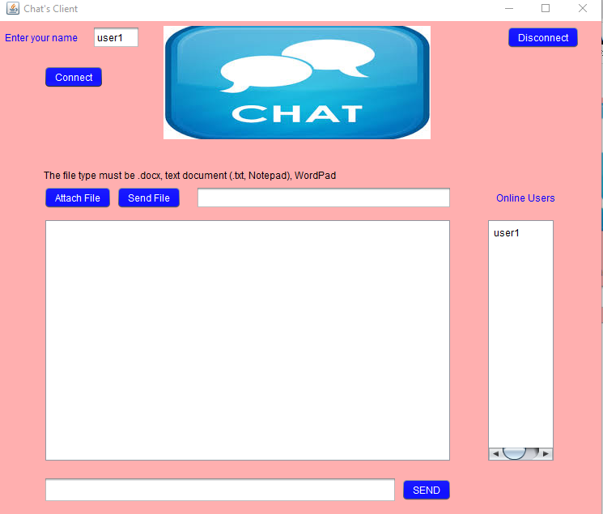

Then I type “hi” on the bottom frame and click button (SEND).The message will be appeared on the big frame.

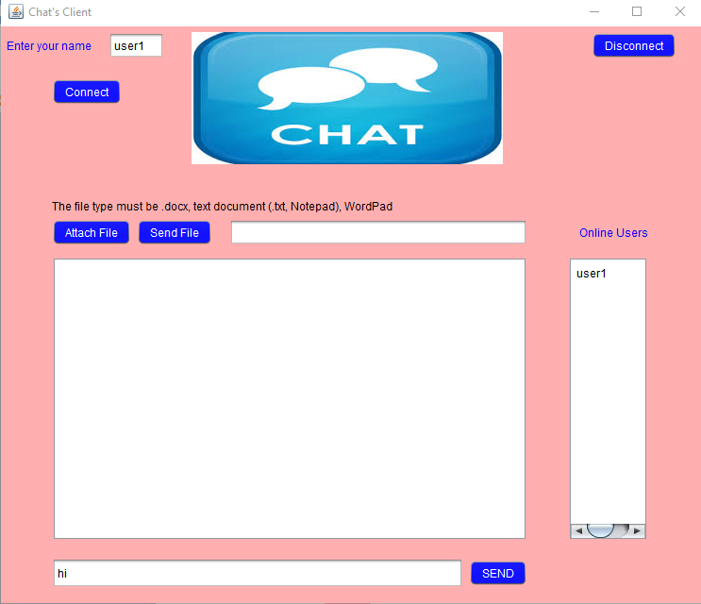

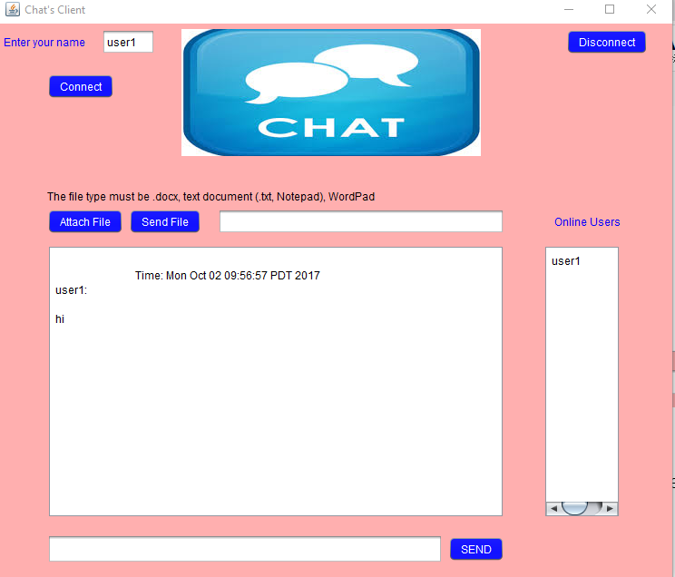

Then I click button (Attach File) and open file, the file name will be appeared on the top frame. Then I click button (Send File), the content of file will be appeared on the big frame.

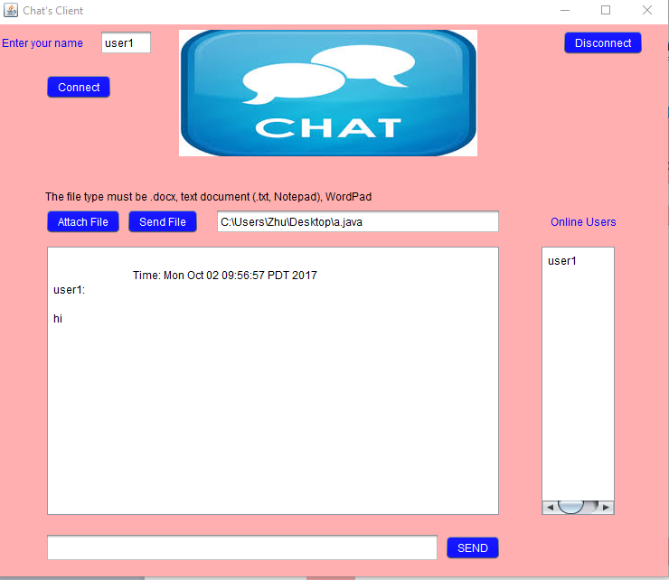

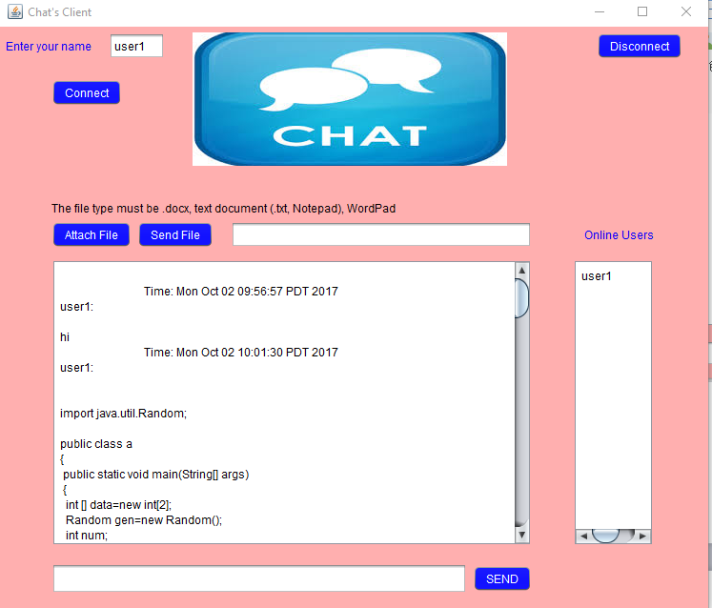

When I run another output for client_frame.java and I enter new name and click button (Connect)

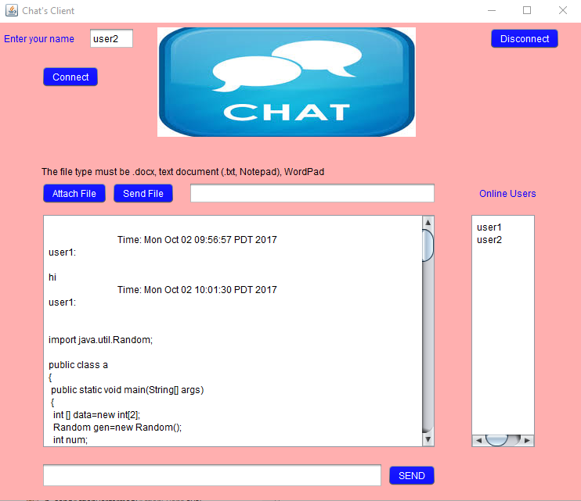

When I click button (Disconnect), the name will be disappeared from right frame.